**West Coast Collaborative**

Mathematics Specialist Unit 4

Test 5 2018: Applications of Differentiation

**Student Name:** _____________________________

**Section One – calculator-free section**

**Time allowed for this task:** 30 minutes, in class, under test conditions.

All electronic devices must be switched off and stored in students’ bags.

**Materials Provided:** SCSA Formula Sheet

**Materials required:** (to be provided by the student)

Standard items: Pens (blue/black preferred), pencils (including coloured), sharpener, correction fluid/tape, eraser, ruler, highlighters.

**Marks available:** 30 marks

**1. [2, 4, 2 = 8 marks]**

**a)** If $x^{2}-xy+y^{3}=8$, determine an expression for $\frac{dy}{dx}$.

**b)** For the curve $x^{3}+y^{3}=35$, determine the equation of the tangent to the curve in exact form that is

**i)** at the point with an $x-$ value of 2,

**ii)** parallel to the $x$-axis.

**2. [2, 3 = 5 marks]**

Solve the following differential equations:

**a) $\frac{dy}{dx}=\sin^{2}x$**  , given that $y\left(0\right)=\frac{1}{2}$

**b) $\frac{dy}{dt}=2e^{2t}-e^{-t}$** , given that $y=2.5 when t=ln2$

**3. [5 marks]**

Use separation of variables and partial fraction techniques to determine the particular solution to

$\frac{dy}{dx}=\frac{3y-xy}{x^{2}-1}$, given that $y\left(0\right)=1$.

**4.** **[1, 4 = 5 marks]**

The slope field for the differential equation $\frac{dy}{dx}=x\left(y-1\right)$ is shown below.

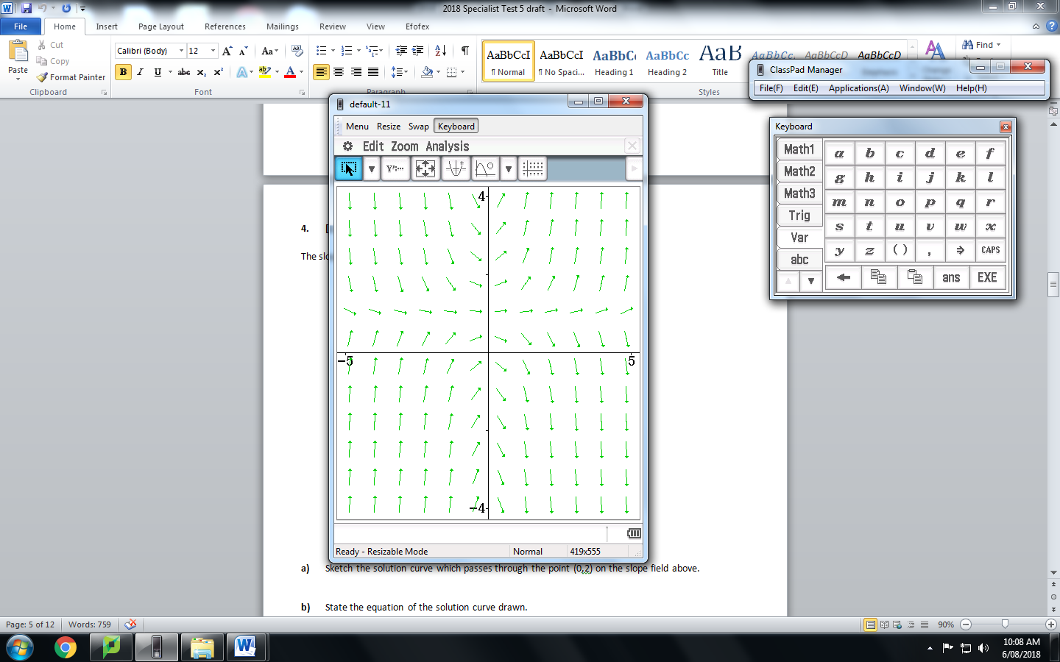

**a)** Sketch the solution curve which passes through the point (0,2) on the slope field above.

**b)** State the equation of the solution curve drawn.

**5. [ 2, 3, 2 = 7 marks]**

A particle moves with velocity ms-1 , where is the displacement. The particle is initially 2 metres to the right of the Origin.

**a)** Show that the particle has constant acceleration.

**b)** Express $x$ in terms of $t$.

**c)** Express $v$ and $a$ in terms of $t$.

**End of Section One**

**West Coast Collaborative**

Mathematics Specialist Unit 4

Test 5 2018: Applications of Differentiation

**Student Name:** _____________________________

**Section Two – calculator-assumed section**

**Time allowed for this task:** 25 minutes, in class, under test conditions

**Materials Provided:** SCSA Formula Sheet

**Materials required:** (to be provided by the student)

Standard items: Pens (blue/black preferred), pencils (including coloured), sharpener, correction fluid/tape, eraser, ruler, highlighters.

Notes on one unfolded sheet of A4 paper.

Special items: Drawing instruments, templates, and up to three calculators approved for use in WACE examinations.

**Marks available:** 25 marks

**6. [6, 2 = 8 marks]**

A spherical raindrop is formed by condensation. In an interval of 40 seconds its volume increases at a constant rate from 0.032 mm3 to 0.256 mm3.

**a)** Determine the rate, to two decimal places, at which the surface area of the raindrop is increasing when the radius is 0.5 mm.

**b)** Using the incremental formula, estimate how much larger will the surface area be when the radius increases from 0.5 mm to 0.55 mm ?

**7. [1, 4, 2, 2 = 9 marks]**



The population of thorny devils in a remote area has a growth rate of 10% with a limit of 3000.

**a)** Based on this information, **c**onstruct a logistic differential equation for this situation in the form $\frac{dP}{dt}=aP(b-P)$,

where $t$ represent the time in years from now.

**b)** The population is currently 500. State the solution as a logistic function ie. write P as a function of $t$.

**c)** Determine the expected population after 8 years.

**c)** Determine the expected time for the population to reach 2000.

**8. [ 3, 5 = 8 marks]**

A cool room for storing food is refrigerated so that the temperature in the room, *F*, in degrees Celsius, at *t* hours after midnight, is given by the formula  
 *F* = −4 cos $\frac{π(t-3)}{12}$ for 0 ≤ *t* ≤ 24   
  
**a)** Show that *F* experiences fluctuations that are similar to a particle undergoing simple harmonic

motion.

**b)** The refrigeration system automatically switches on when the rate of change of   
 temperature, with respect to time, is greater than or equal to 0.5°C/h. When the rate of   
 change of temperature, with respect to time, is less than 0.5°C per hour it automatically   
 switches off again. Find the actual times (e.g. 2.17 a.m.), to the nearest minute, at   
 which the system switches on and then switches off, during a 24 hour period.

**End of Section Two**